Scoil Íosagáin Infant School
Spa Glen, Mallow, Co. Cork. Tel. No. 022-42766

Book List 2022 - 2023 SENIOR INFANTS
Books to be purchased
Subject | Item
English | - Sounds Make Words – Senior Infants (Folens)  - Mrs. Murphy’s Handwriting Book B Precursive (Edco)
Maths | - Planet Maths Senior Infants (Folens) (2 books in pack)
Gaeilge | - Bua na Cainte Workbook B (Edco)
Religion | - Grow in Love Pupil Book-Senior Infants
- Colouring Book ( Child’s own choice)
LABEL ALL BOOKS ON FRONT COVER WITH CHILD’S NAME
➢
o Please bring all books to school clearly labelled with child's name and room number/ teacher’s name on first day of school.
o Please cover books in plastic to allow child to recognise books.

Stationery
Pencils  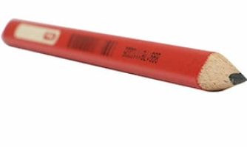  4 x red triangular pencils (pupils name on each pencil) | Folders  3 x A4 envelope folders with fastener  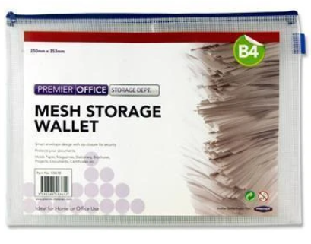
Triangular Sharpener x 1  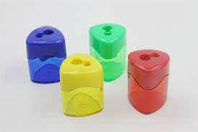 | Eraser x 1  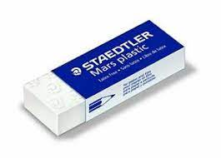
Duster  Duster (soft based sponge/cloth).  (Do not give your child a washing up scrubber as these scratch the whiteboards. Thank you.) | Copies  - 1 x 120 page copy  - 2 blank copy  - 3 x 15A copies
  Glue  2 x Large Pritt Sticks  (labelled  with child’s name on each) | Plastic envelope  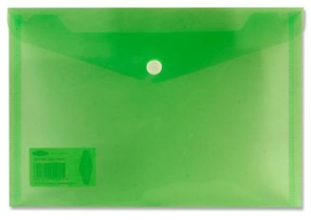  2 x A5 size plastic transparent envelope  (for cut out words).
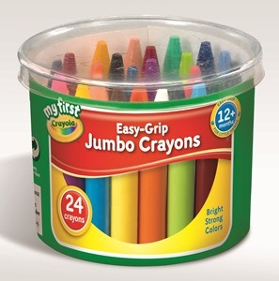  Crayons  Crayola My First Crayons Easy Grip -24 | Whiteboard Markers  8 x thick dry wipe whiteboard markers (non permanent) . Staedtler are best.  (Labelled with child’s name on them)  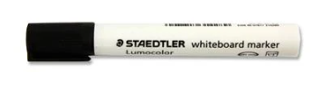
Playdoh  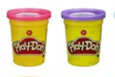  3 x individual cans | Please label all items.  Labels on tracksuit jumpers can fade in the wash- please ensure that they are labelled at all times.

Uniform: Tracksuit
Our uniform is the  - Tracksuit and yellow polo shirt.  - Tracksuits are available in  - Philips Book Shop in Mallow.  - School shorts or navy leggings may be worn for hotter weather.  - Velcro Runners are preferable for infants.  - Please avoid using trolley bags. Shoulder bags only. | 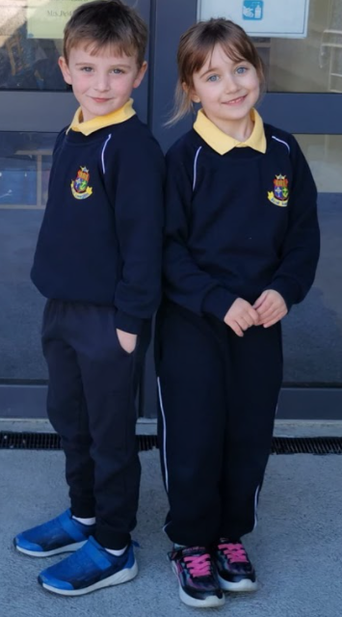

School Contribution: €70-requested to transfer by Aladdin payments
(link will be sent by text in due course-payment due prior to September 1st 2022)
- This covers pupil insurance, book rental, Sight & Sounds book, art materials, photocopying, English Readers, PM readers, Aladdin Connect and assessment booklet.

