Scoil Íosagáin Infant School
Spa Glen, Mallow, Co. Cork. Tel. No. 022-42766

Book List 2022 - 2023 JUNIOR INFANTS
Books to be purchased
Subject | Item
English | - Sounds Make Words-Phonological Awareness(Folens). Pre-sounds A4 book yellow cover.  - Just Phonics. 26 sounds. (Educate plus)  - Mrs Murphy’s Junior Infant Copies (Edco)
Maths | - Planet Maths Junior Infants (Folens) (2 books in pack)
Gaeilge | - Bua na Cainte Workbook A (Edco)
Religion | - Grow in Love Pupil Book-Junior Infants
- Colouring Book ( Child’s own choice)

LABEL ALL BOOKS ON FRONT COVER WITH CHILD’S NAME
➢ Books:
o Please bring all books to school clearly labelled with child's name and room number/ teacher’s name on visit day 25th August, 2021.
o Please cover books in plastic to allow child to recognise books.

Stationery
Pencils  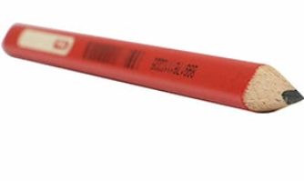  4 Junior grip pencils (pupils name on each pencil) | Folders  3 x B4 envelope folders with fastener  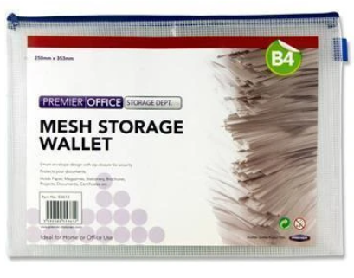
Duster  Duster (soft based sponge/cloth).  (Do not give your child a washing up scrubber as these scratch the whiteboards. Thank you.) | Copies  3 x Junior Blank copies  2 x 15A Project copies
  Glue  2 x Large Pritt Sticks  (labelled  with child’s name on each) | Plastic envelope  2 x A5 size plastic transparent envelope  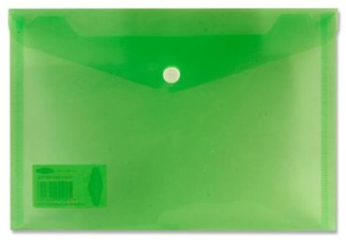  (for cut out words).
Crayons  Crayola My First Crayons Easy Grip -24  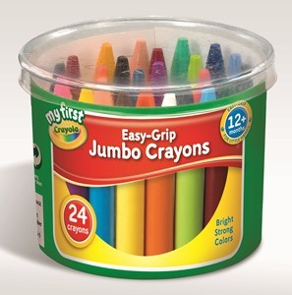 | Whiteboard Markers  2x4 pack thick dry wipe whiteboard markers (non permanent)  (Labelled with child’s name on them)  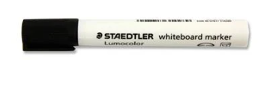
Playdoh  2 x individual cans  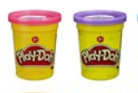 | Please label all items.  Labels on tracksuit jumpers can fade in the wash- please ensure that they are labelled at all times.

Uniform: Tracksuit
Our uniform is the  - Tracksuit and yellow polo shirt.  - Tracksuits are available in  - Philips Book Shop in Mallow.  - School shorts or navy leggings may be worn for hotter weather.  - Velcro Runners are preferable for infants.  - Please avoid using trolley bags. Shoulder bags only. | 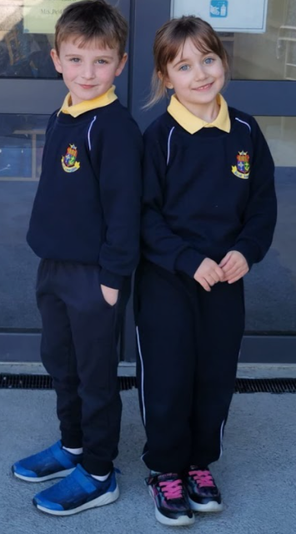

School Contribution: €70-requested to transfer by Aladdin payments
(link will be sent by text in due course-payment due prior to September 1st 2022).
- This covers pupil insurance, book rental, Sight & Sounds book, art materials, photocopying, English Readers, PM readers, Aladdin Connect and assessment booklet.

